**WEEK-2 (ICT502)**

**Student ID: S20241757**

**Student Name: RAHUL TUNDIYA**

**Answer: Task-2**

**Code:**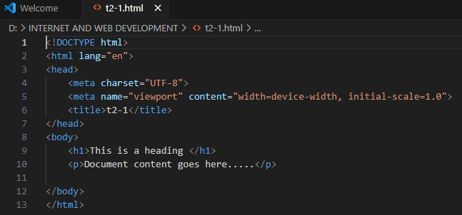

**Output:**

**Answer:Task-3**

**Code:**

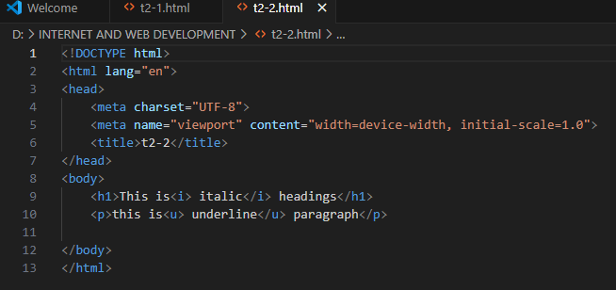

**Output:**

**Answer: Task-4**

**Code:**

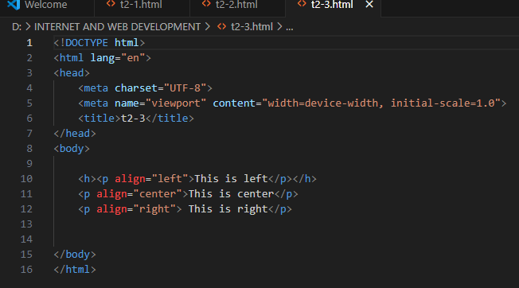

**Output:**

**Answer: Task-5**

**Code:**

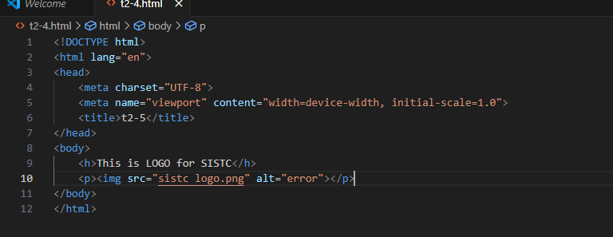

**Output:**

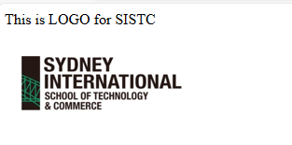

**Answer: Task-6**

**Code:** 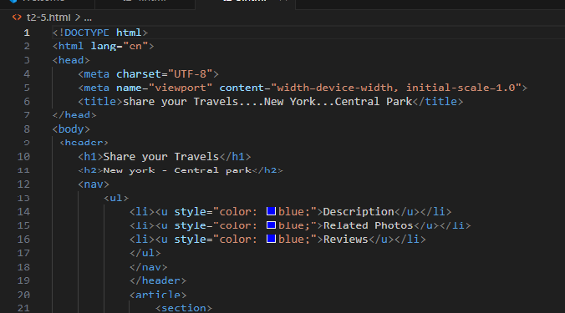

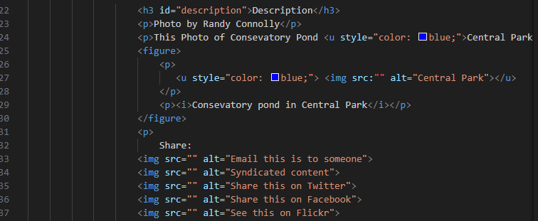

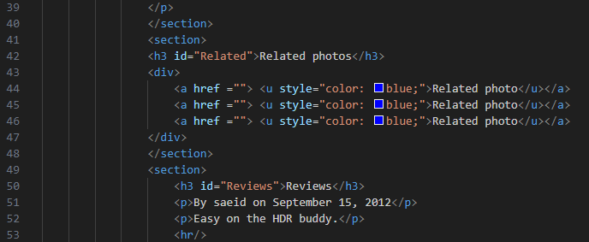

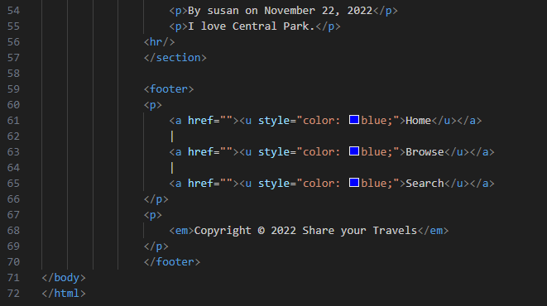

**Output:**

